Article Title: Ruble hits 8-month low against dollar, as falling oil prices and sanctions bite

Key Concept:

Source: CNN Business

URL: <https://www.cnn.com/2022/12/29/investing/ruble-dollar-russia-oil/index.html>

Name: Westly Bouchard

Word Count: TBD

Date of Commentary: 1/12/22

Section: International Economics

Russia’s currency hit an eight-month low Thursday, adding to sharp declines in December as global oil prices fell, and Western sanctions targeted Russia’s energy sector.

The ruble hovered below 72 to the dollar, down 18% from the start of the month, and its weakest level since late April.

After almost halving in value in the first weeks of the war, the ruble has held up remarkably well for most of the year, trading within a narrow range. The ruble has been helped by measures from Russia’s central bank, which more than doubled interest rates at the start of the war, introduced [capital controls](https://www.cnn.com/2022/04/29/investing/russia-ruble-dollar-debt-payment/index.html), and forced exporters to convert 80% of their earnings into rubles, artificially creating demand for the currency. It later rolled back some of those policies as the exchange rate stabilized.

But with the price of oil, Russia’s biggest export, down by about a third from its June peak, and an EU embargo on seaborne oil, and [Western price cap](https://www.cnn.com/2022/12/02/energy/russia-oil-price-cap-europe/index.html) mechanisms now in place, Russia’s oil export revenues are likely to fall. This means less foreign currency to prop up the ruble.

The International Energy Agency said this month that Russian oil export revenues fell by $700 million in November because of falling prices.

President Putin [signed a decree](https://www.cnn.com/2022/12/27/energy/russia-oil-ban/index.html) this week [banning oil sales](https://www.cnn.com/2022/12/05/energy/russia-oil-embargo-price-cap-explainer/index.html) to countries or entities complying with the price cap, and his deputy Prime Minister warned the country may have to cut oil production by up to 7% in 2023.

Russia’s Finance Minister Anton Siluanov said Thursday that the exchange rate was stabilizing, though “small fluctuations” remained.

“The point is, our imports are increasing” he told Russian state TV in an interview that aired on Thursday. “Our exchange rate is floating and depends on the situation with the balance of payments.”

He said Russia’s new budget rule in force from next year would allow it to use excess oil revenues to stabilize the currency if necessary.

In response to Russia’s invasion of Ukraine, western countries imposed **economic sanctions** (actions taken against the economy of another country) on the country, specifically its energy sector and oil production economy. This has caused the value of the Russian currency, the ruble, to **change**, and fall in comparison to the dollar as demand for the currency decreased on the foreign exchange market, shown on the diagram as the change from $P_{1}$ to $P_{2}$.

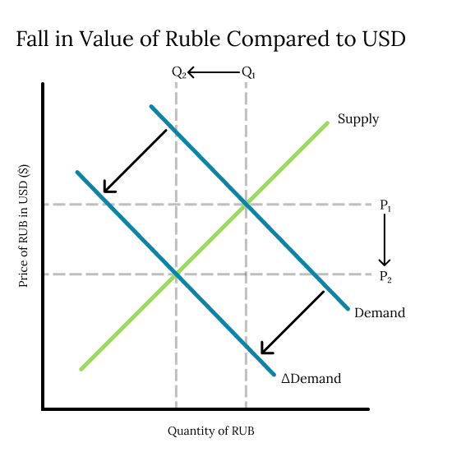

In addition to this, Russia’s export revenues, specifically in the energy sector, have fallen significantly, leading to a deficit in the current account. Because the ruble’s exchange rate is **floating** (allowed to regulate itself) this deficit in the current account implies that there is an excess of supply of the ruble on the foreign market. With excess supply on the forex market, there is downward pressure on the ruble’s exchange rate. With the combined effects of these two situations, the ruble has fallen to around 72 to the dollar as mentioned in the article.

The main disadvantage in this situation is inflation. Because the ruble is worth less compared to the currencies of the countries that Russia trades with, they will have to pay more for the same amount of product. Additionally, in this situation, Russia is not able to take advantage of the possible benefits of a low exchange rate. One of these possible advantages is that employment will increase in export industries because exports from the country will be relatively cheaper due to the low exchange rate. However, because this change in exchange rate was a result of sanctions from other countries, Russia would not have anywhere to export to in the first place.

In an attempt to remedy the situation, the Russian government has taken three important actions in order to **change** the value of the Ruble, and stabilize or raise its value. They have raised interest rates in the country, implemented **capital controls** (regulations to limit the flow of capital in and out of the country), and forced exporters to convert their earnings into rubles.

By raising exchange rates, the Russian government can make their domestic interest rates higher than those of foreign countries. This should attract financial investment from other countries, as a high interest rate is desirable when investing money. If a country wants to take advantage of the higher interest rates, they will have to buy rubles, increasing demand for the currency on the foreign market, and therefore raising its exchange rate in comparison to currencies like the dollar or euro.

In terms of capital controls, the Russian government is preventing Russian brokers from selling securities held by foreign investors. This means that rubles are prevented from leaving the economy, somewhat limiting the supply of the ruble on the foreign exchange market. By attempting to limit supply on the foreign market, the situation of excess supply is controlled, and the market for the ruble can return to equilibrium, raising its exchange rate.

Finally, the government is forcing exporters to convert earnings into rubles. Foreign consumers are being forced to make payments for Russian exports in rubles. To do this, they will have to purchase rubles on the foreign exchange market, increasing demand for the currency, and raising its exchange rate.

All of these actions taken by the Russian government are attempts at inflating demand for the currency on the foreign exchange market. By doing this, the exchange rate for the ruble will rise, or at the very least, stay constant. This can be seen in the diagram below, where the actions by the Russian government have pushed the demand curve for the ruble on the foreign market to the right, raising its price in terms of the US Dollar, increasing its exchange rate.

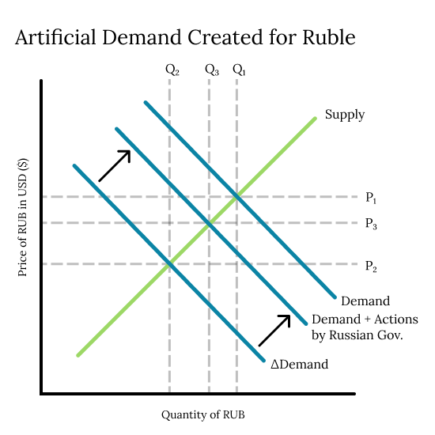

However, there are some possible negative effects of using interest rates to control an exchange rate, as the Russian government has done. The most concerning of which is the potential for aggregate demand within the Russian economy to fall. When interest rates rise, it becomes more expensive to borrow money. This means that less money is invested, and consumption falls. Because these are core components of aggregate demand, aggregate demand could fall in the Russian economy, sending the country into a recession. This has the potential to negate the efforts of the Russian government, as a recession could bring greater inflation to the ruble, and decrease its exchange rate on the foreign market. This situation connects to the key concept of change, as it represents the change in the value of the Russian currency when compared to other currencies, as well as the changes to the Russian economy that come with the peaks and valleys of the ruble’s value.